Minutes of the Seventh Client Meeting

MCI Team 21

Tuesday 11th May 2021

**Chair** Yupeng Hou

**Secretary** Ying Li

**Members** Ying Li, Yupeng Hou, He Zhang, Wei Qin

**Apologies** All team members attended the seventh client meeting.

# Time and Place

The *seventh* client meeting for the Master of Computing and Innovation Project was held in **Ingkarni Wardli** at **3:30pm on Tuesday 11 May 2021**.

# Quorum Announcement

The Chairman announced that a quorum of the group was present, and that the meeting, having been duly convened, was ready to proceed with its business.

# Summary of Previous Meeting

The previous meeting is the sixth client meeting. We presented the functionalities that we implemented, including the filter function and the function of managing researchers.

Clients gave us some important feedback and provided new requirements.

* Completely implement the function of managing researchers.
* Display the researcher list on the webpages, which could help users to check the name and PID.
* As a user, I hope I can edit the entry of BibTex and all changes are made globally. For example, Note={https://........}.
* Add URL for each article. As a user, when I click it, it will jump to the original website.

# Group milestone

## Overview

Our team develop the project according to the clients’ feedback and implemented the required functionalities on time.

## Detailed Presentation

Redesigned the user interface (Figure 1). Now the navigation bar adapts to various screen sizes (Figure 2), the height of window is fixed, and the footer is fixed at the bottom.

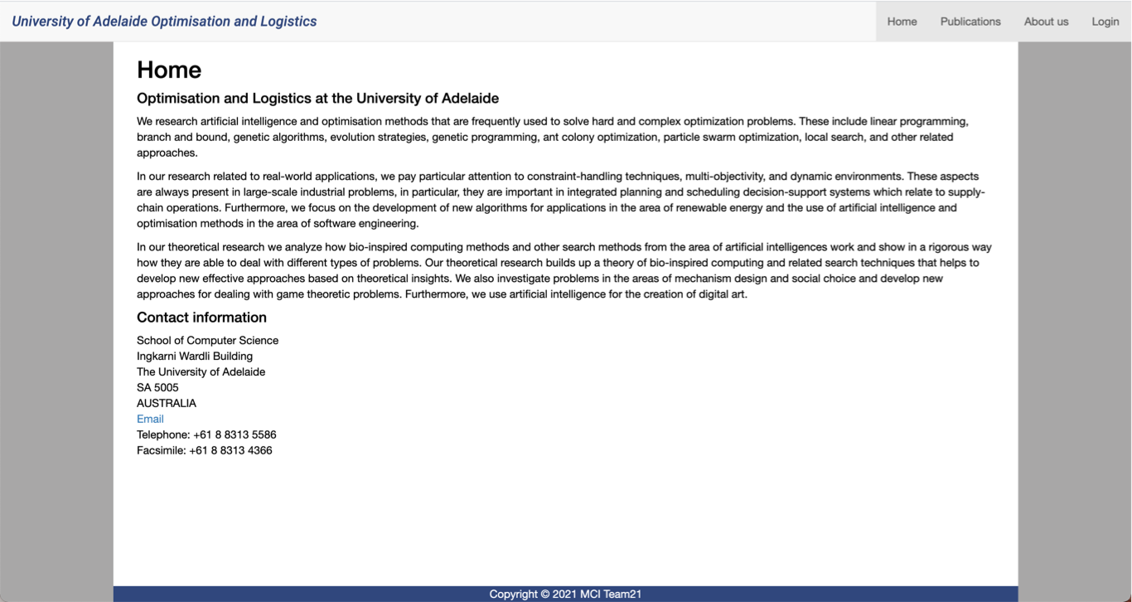

Figure 1. New version of user interface

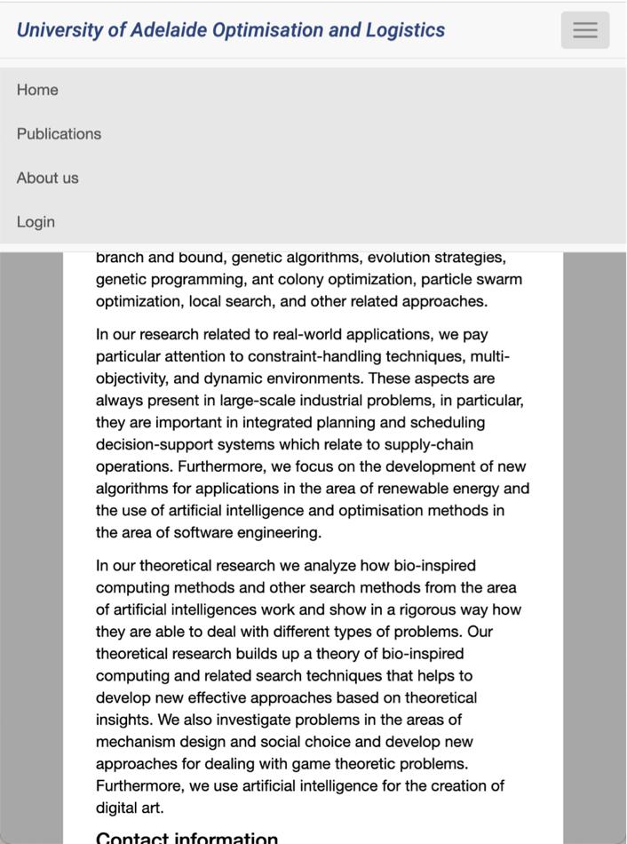

Figure 2. Fully responsive navigation bar

• Fully completed the function of managing researchers, including add researchers (Figure 3) and remover researchers (Figure 4). The researcher list is shown in the webpage, which is convenient for users to check.

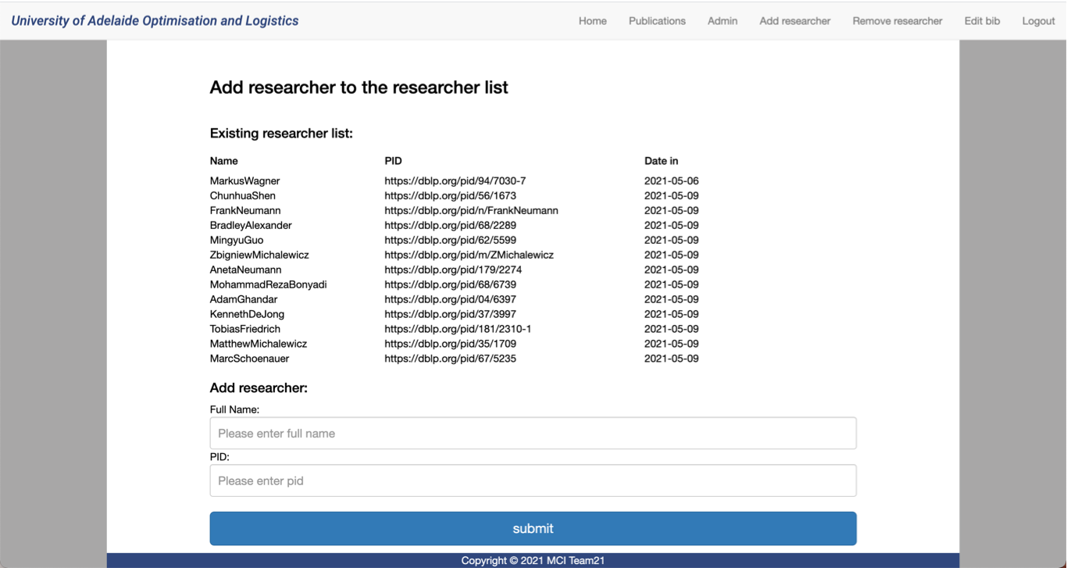

Figure 3. Add researcher

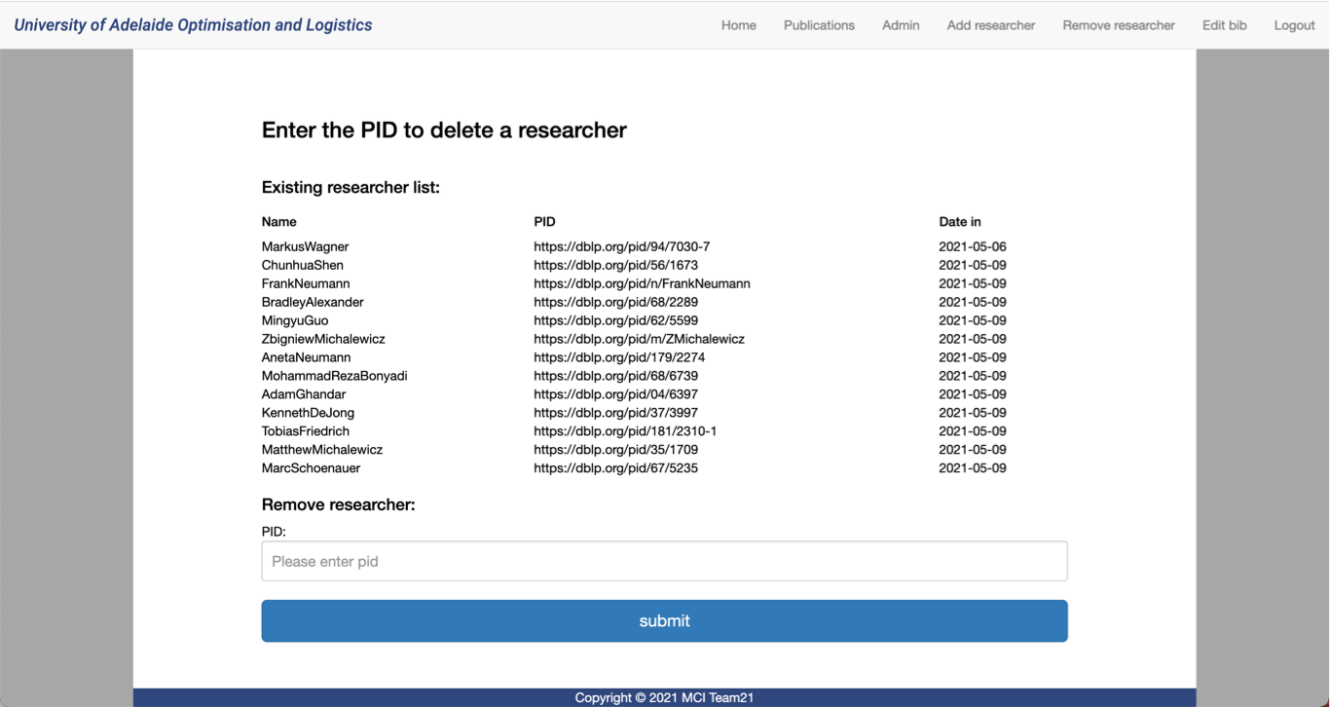

Figure 4. Remove researcher

• Completed the function of editing BibTex (Figure 5). This feature is only available when the user is logged in. To be specific, when the user logs in, there will be an “edit” button at the end of each article (Figure 6). When the user clicks the button, it will jump to the webpage named Edit bib automatically.

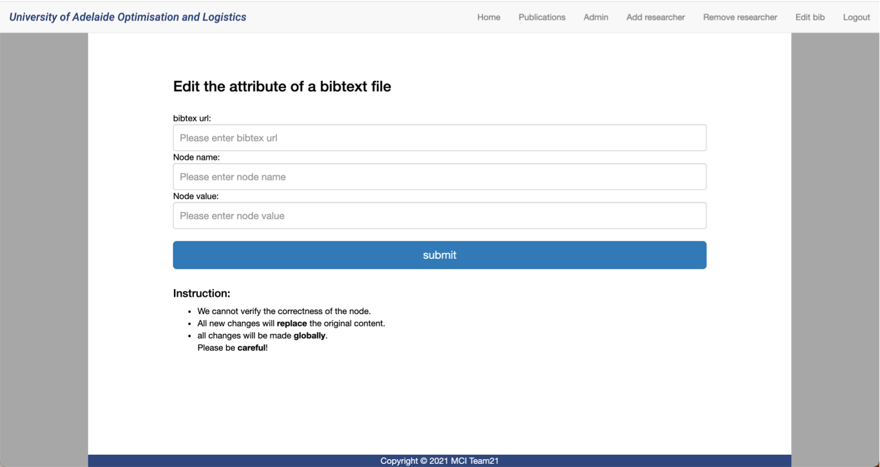

Figure 5. Edit BibTex

Default URL field.

Button for Edit function.

Figure 6. The user interface of administrator

* The default URL is shown in the Available field. When users click the name of articles, it will jump to the original website.
* Years, the name of group members and conferences are bold. When users click them, it will jump the corresponding webpages. To be specific, when you click Frank Neumann in the first article in Figure 6, it will jump to Frank’s webpage.

# Individual Milestone Reports

Before the sixth client meeting, all team members finished their tasks on time. The detailed tasks have been recorded in the Project on GitHub.

Wei Qin:

# Implemented the edit BibTex file in the backend.

# Completely finished the managing researchers’ function.

# Displayed the researcher list in the management webpages including add_ researcher.html and remove_researcher.html.

Ying Li:

# Refactored the code in CSS and redesign the navigation bar.

# Designed the user interface of management webpages and add more instructions.

# Designed the style of displaying each publication. Add available URL for each publication.

# Designed the structure of the website. Remove Researchers.html, Projects.html, Search.html and add admin.html.

# Yupeng Hou:

# Finished the function of editing BibTex entries. All changes will be recorded in the append.txt file. When parsing the BibTex file, parser will check the fields. If they are different, it will use the local fields. If there is a new field, the new field will be added to the bottom of the entry.

# Debug the python, c++ and front-end program.

# Added link to years, conferences and researchers for each publication. Users could jump to the corresponding webpages.

# He Zhang:

# Wrote the project overview in the testing plan.

# Fixed bugs in c++ files.

# Did more researching jobs about testing.

# Requirements Elicitation

## 6.1 Client Requirements

* Prepare to deploy the project in the server of the university.
* Refactor code in parser part.
* Limit the login time.
* Define the update interval, which may be weekly. It could improve the efficiency of acquiring data from DBLP.

## 6.2 Lists of Tasks to do

|  |  |  |  |
| --- | --- | --- | --- |
| Action | Assigned to | Due date | Status |
| Discuss the client requirements | All team members | 11/May/2021 | End |
| Write meeting minutes | Ying Li | 12/May/2021 | End |
| Meeting with tutor and receive the feedback | All team members | 12/May/2021 | In process |
| Display log in the webpage | Ying Li & He Zhang | 13/May/2021 | In process |
| Limit the login duration | Wei Qin & Yupeng Hou | 15/May/2021 | In process |
| Define the update interval | Wei Qin | 16/May/2021 | In process |
| Deploy the project to the server of our university | Wei Qin | 17/May/2021 | To do |
| Refactor the code in c++ | Yupeng Hou & He Zhang | 17/May/2021 | In process |
| Format the code of parser and add more comments | He Zhang | 17/May/2021 | In process |
| Design test cases | All team members | 18/May/2021 | In process |

# Adjournment

The next meeting is a *group* meeting and will be held in **Ingkarni Wardli** at **3:30pm on Tuesday 18 May 2021**.

The meeting closed at 4:00pm.